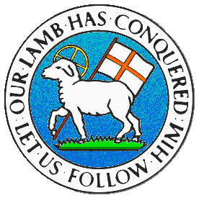
CHILDREN BROCHURE

MORAVIAN CHURCH – BARBADOS CONFERENCE
Provincial Theme: Advance the Kingdom: S.H.I.F.T.

S. – Seek & Submit
H. – Hear & Heed
I. – Imagine & Insight
F. – Focus & Function
T. – Totally Transformed

Age: 7 yrs. & Under
S.H.I.F.T.

November 28

Scripture:

Ecclesiastes 3:1 To everything there is a season, and a time to every purpose under the heaven. (IKJV)

Message:

There are times when we feel as if we are in the wrong place at the wrong time. Or we could have done things differently, maybe we feel our timing was wrong with things not working out the way we thought they would. We sometimes try to do things at the wrong time and expect it to turn out right. We may not be sure if what we are doing is the right thing at the right time. However, we have to trust God to direct us and guide us in the right way.

Once the things we do are right in His sight, God will show us the right time and even the right place. We have to trust Him to go before us to prepare the place to receive us. We can also trust Him to prepare us to face the many trials we may face as we move forward. As the plans God has for us unfolds, everything has an order so we can be sure that as thing happen around us, God is in control. We should not try to do our own thing, when we feel like and how we see fit. There is a time and season for everything and we must also learn to put away the things, people and events that are not of God and focus on what He has planned for us.

Activity:

Place one of these letters (a, e, i, o, u) in the missing spaces

There is a time and purpose for doing everything. A time to:

- S _ n g
- L _ _g h
- P r _ _ s_
- D _ n c _
- S h _ _ t
- P r _ y

(Answers next week)

(Answers from last week)

- Be True
- Be Fair
- Be Honest
- Be Loyal
- Be Meek
- Be Holy
- Be Strong
- Be Right
- Be Real
- Be Just
- Be Kind

