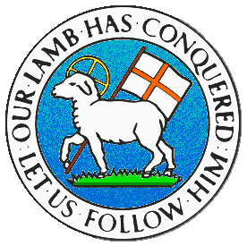
CHILDREN BROCHURE

MORAVIAN CHURCH – BARBADOS CONFERENCE
Provincial Theme: Advance the Kingdom: S.H.I.F.T.

S. – Seek & Submit
H. – Hear & Heed
I. – Imagine & Insight
F. – Focus & Function
T. – Totally Transformed

Age: 7 yrs. & Under
S.H.I.F.T.

March 28

Scripture:

Matthew 5:10 "Blessed are those who are persecuted for righteousness' sake, For theirs is the kingdom of heaven”. (NKJV)

Message:

Do some of your friends pick at you even when you try to do the right thing? Some do not have anything good to say to you or about you when you always do what is right. No matter what you do, it always makes them unhappy and they in turn try to make you unhappy. Understand that it is important to first of all to please God, not your friends. Your friends do not have control over your life, only Jesus Christ can direct you right at all times and in the right way. There are also family members and some friends who will look out for you and give you good advice.

Learn to tell the difference between persons who care for you and want what is best for you and those who do not care for you. Those who have nothing good to say about you may hurt your feelings. But once you are right, you will be blessed and the kingdom of heaven will be yours. So keep on doing the right things, pray for them so that they too will have a change of heart and will be able to have the reward of the kingdom of heaven also. Don’t worry if others try to distract you, just continue to always walk with Jesus.
Activity:

S | P | E | K | T | C | O | R | D | A | L | V | U | W | N

Replace the symbols below from the table above.

Jesus
Jesus
Jesus
Jesus
Jesus
Jesus
Jesus
Jesus
Jesus
Jesus

Jesus is the !!

(Answers next week)

(Answer from last week)

Blessed are the pure in heart, for they shall see God.

