

CHILDREN BROCHURE

MORAVIAN CHURCH – BARBADOS CONFERENCE

Provincial Theme: Advance the Kingdom: S.H.I.F.T.

S. – Seek & Submit

H. – Hear & Heed

I. – Imagine & Insight

F. – Focus & Function

T. – Totally Transformed

Age: 13 yrs. & Over

SUBMIT

June 7 – Submit to Patience

Scripture:

Let us sing:

I Am Determined To Hold on To The End

I am determined to hold on to the end,  
Jesus is with me, on Him I can depend,  
And I know I have salvation, for I feel it in my soul,  
I am determined to hold on to the end.

Hold on, hold on, hold on, hold on,  
Hold on, hold on, hold on, hold on,

I am determined to hold on to the end.

Memory Verse:

Romans 8:25 (NIRV)

 We hope for what we don’t have yet. So we are patient as we wait for it.

Reading from the Bible: (Read with me)

Isaiah 40: 29 - 31  (NIRV)

29He gives strength to those who are tired.  
    He gives power to those who are weak.  
30 Even young people become worn out and get tired.  
    Even the best of them trip and fall.  
31 But those who trust in the Lord will receive new strength.  
 They will fly as high as eagles. They will run and not get tired.  
    They will walk and not grow weak.

Message:

**Let’s talk about it:**

This week, our study is to submit to patience. Our first thought is: What is Patience?

Patience may be defined as a person's ability to wait something out or endure something tedious, without getting riled up. Having patience means you can remain calm, even when you've been waiting forever or dealing with something painstakingly slow or trying to teach someone how to do something and they just don't get it. How many of you went shopping with your parents in the early days of the lockdown? Or even watched the news showing how shoppers patiently stood in those long lines waiting to get into the supermarkets. Do you have that patience?.

I was hoping that you would have said “Yes!”

 Patience is the quality of waiting calmly without complaining. What we want to stress here is that patience is not passive resignation, nor is it failing to act because of our fears. Patience means active waiting and enduring. It means staying with something and doing all that we can﻿—working, hoping, and exercising faith; bearing hardship with fortitude, even when the desires of our hearts are delayed.

Impatience, on the other hand, is a symptom of selfishness. Anger and stress are two things that are enough to ruin a person's health. Patience is an important tool in overcoming frustration.

Have you been trying to make something and it just will not come out correctly. You are trying to bake a cake, but no matter what you do, your cake looks nothing like the one in the book. You are completing a word find, but no matter what, you are not seeing two words. You are completing a mathematics problem, but it just is not coming out. Patience will say, do not give up. Let it rest a bit and come back to it later. Isaiah tells us in chapter 40, “He, meaning God, gives strength to those who are tired.  He gives power to those who are weak.” Ask God to help you. Ask God for the strength to get you through those difficult moments.



You have joined the Gym class. How much weights can you lift? I am sure that your instructor will restrict the weights at first. No need to injure yourself. Take it easy. Take your time. You will be able to increase your weights over time. Have patience.

Isaiah goes on to tell you, “*trust in the Lord and you will receive new strength, you will fly as high as eagles, you will run and not get tired, you will walk and not grow weak.”*

When you submit to the patience that only God can supply, then your frustrations will cease, your success will grow. In Paul’s letter to the Philippians, Chapter 4, verse 6, he told them “***6****Don’t worry about anything. No matter what happens, tell God about everything. Ask and pray, and give thanks to him*.”  That verses is simply telling you not to get anxious or frustrated when things are not going your way. If you ask and pray, you will get whatever is for you. Be patient when you ask for something, be patient when your success seems way out, be patient with your friends and with your siblings.

Let close with a quote worth remembering:

“All things come round to him who will but wait.”

[***Henry Wadsworth Longfellow***](https://quotes.yourdictionary.com/author/henry-wadsworth-longfellow/) ***(1809 -1883)***

**Let us pray for patience:**

Lord, teach me to be patient with life, with people, and with myself. I sometimes hurry too much, and I push for answers before the time is right. Teach me to trust your sense of timing rather than my own and to surrender my will to your wiser plan. Amen

Activity:

1. Try to move through this maze, just going from one end to the other. Try to do it in less than 5 minutes. Never mind if you don’t. Just keep trying.



2. Unscramble the following letters to give you words that you met in this study.

Copy the letters in the numbered cells to other cells with the same number.

Why don’t you challenge a friend to complete this page?

Submit to Patience

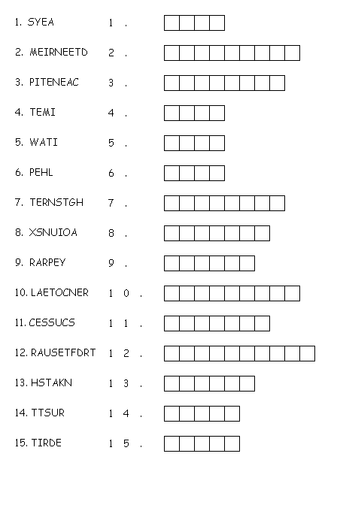

(Answers next week)