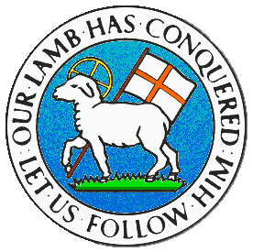
CHILDREN BROCHURE

MORAVIAN CHURCH – BARBADOS CONFERENCE
Provincial Theme: Advance the Kingdom: S.H.I.F.T.

S. – Seek & Submit
H. – Hear & Heed
I. – Imagine & Insight
F. – Focus & Function
T. – Totally Transformed

Age: 8 – 12 yrs.
S.H.I.F.T.
June 20

Scripture:

Luke 8:16 No one lights a lamp and then covers it with a bowl or hides it under a bed. Instead, he puts the lamp on a lampstand so that those who come in will have enough light to see. (ICB)

Message:

When you put on a light, the darkness goes away and you can see where you are going. If you lost something in the dark, the light would help you to find it. Light is important to help us find our way. There are many examples of darkness in life and every time we sin, we keep ourselves in darkness. To get out of the darkness, we must call upon our Saviour Jesus Christ who has already paid the price for our sin by dying on the cross. We simply need to confess our sins to Jesus and He will forgive us, then He will give us light since He is the light of the world.

As our sins are forgiven and we become lights, we are not to hide the light from others. At night when we put on the lights in the house, it makes the place brighter as if it was daytime. So it is we must make our light, the light of Jesus Christ shine for all near to us to experience the light of the Lord. If you hide your light, someone may stumble and fall and you may miss the opportunity to be a blessing. Do not cover up your light, instead lift it up high, shine for the Lord so many would see by your example Jesus is indeed the light of the world.

Activity:

See how many you can find.

A light for Jesus carries and brings:

C _ _ e C _ _ f _ _ t
J_ _ f _ _ n _ _ s K _ _ _ n _ _ s
L _ _ _ H _ _ _ l _ _ y
H _ _ m _ _ y G _ _ _ n _ _ s
R _ s p _ _ t B _ _ _ ty
Con _ _ _ _ m _ _ t P _ _ _ e
Com _ _ _ _ ion Bl _ _ _ i _ _ s
H _ _ e _ _ y P _ _ ie _ _ e

(Answers next week)

