CHILDREN BROCHURE

MORAVIAN CHURCH – BARBADOS CONFERENCE
Provincial Theme: Advance the Kingdom: S.H.I.F.T.

S. – Seek & Submit
H. – Hear & Heed
I. – Imagine & Insight
F. – Focus & Function
T. – Totally Transformed

S.H.I.F.T.

Age: 13 yrs. & Over

June 13
Sing with me:

Every praise is to our God

https://www.youtube.com/watch?v=4yhgrdkrmB0

Memory verse: Luke 8:8 NIRV
8 Some fell into good soil, and when it grew, it produced a hundredfold.” As he said this, he called out, “Let anyone with ears to hear listen!”
Scripture
Luke 8:4 – 8, 11 -15
Read with me
The Parable of the Sower:
4 When a great crowd gathered and people from town after town came to him, he said in a parable: 5 “A sower went out to sow his seed; and as he sowed, some fell on the path and was trampled on, and the birds of the air ate it up. 6 Some fell on the rock; and as it grew up, it withered for lack of moisture. 7 Some fell among thorns, and the thorns grew with it and choked it. 8 Some fell into good soil, and when it grew, it produced a hundredfold.” As he said this, he called out, “Let anyone with ears to hear listen!”
The Parable of the Sower Explained
11 “Now the parable is this: The seed is the word of God. 12 The ones on the path are those who have heard; then the devil comes and takes away the word from their hearts, so that they may not believe and be saved. 13 The ones on the rock are those who, when they hear the word, receive it with joy. But these have no root; they believe only for a while and in a time of testing fall away. 14 As for what fell among the thorns, these are the ones who hear; but as they go on their way, they are choked by the cares and riches and pleasures of life, and their fruit does not mature. 15 But as for that in the good soil, these are the ones who, when they hear the word, hold it fast in an honest and good heart, and bear fruit with patient endurance.
Let us talk about it:
Last week we read about building a house. We said it was all about listening to God and following His word. You were given some daily texts to help you get started in reading God’s word. We are going on this week to look further at how you can stay focused on God. We said last week that Jesus love to tell stories to illustrate His points. These stories are called parables. What Jesus did was to use earthly situations and put a heavenly meaning to it. This week’s story is about a farmer. How many of you have gardens at home? What kind of plants do you have? Vegetables, flowers or ornamental plants? Do you have fun helping with the gardens or the plants at home?
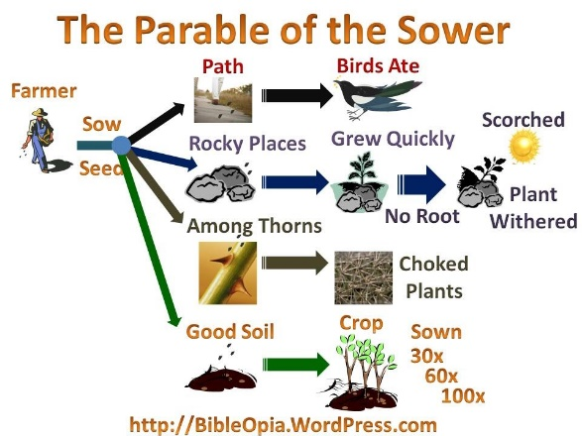
Now Jesus illustrated this story with four different conditions for planting – foot paths, rocks, thorns, and good soil, as shown in the diagram. The seed, He said, was the word of God. The farmer just threw out his seeds. The story did not say if he spent any time preparing the land.
The story tells us some seeds fell on the pathway. Well, what do you expect? Between people trampling the seeds on the pathway and the birds seeing these seeds as food, those seeds had no time to grow. Some people, when they hear the word have no time to absorb it, Quick so, the distractions of the world snatch it away.
What about the seed which fell among the rocks? Maybe the birds did not get these seeds, but the roots could not penetrate the rocks, and the sun just scorched the young plants and the seeds did not manage to grow into plants.
Now, what about those seeds which fell among thorns? They may feel as if they would grow, but they are chocked by all those other plants growing in the same space. Such persons are too concerned with the affairs of the world around them, and have no time to really hear what God is saying. Some of us are so busy with so many activities, we have no time to really listen to what God is saying. On Monday, we go to Maths lessons, Tuesday we go to Karate, Wednesday we go to swimming, Thursday, it is violin, Friday it is Cadets, Saturday it is football or cricket. Sunday, oh dear, we are tired, plus there is homework, so we cannot even go to church. Perhaps, you are chocked with all those activities.
Now we get to those seeds which fell on good soil. Maybe you can say what will happen here. These are the seeds whose roots penetrate the soil. Which people are those? Those are the people who not only hear the word, but they live the life that is given in the word. The teaching of Jesus penetrates their hearts, and their faith is nourished. The more we listen to the words of Jesus, the more we can grow in wisdom and in faith.

As you read the following story, I want you the think of what is happening to Jenny. What advice will you give to Jenny to help decide on the path she should take?
Click on the following link to read the story: The Garden Club
https://www.kidssundayschool.com/gradeschool/stories/the-garden-club

Let us pray:
Almighty God, thank You for sending Your Son, Jesus who taught me how to live the life which will bring me closer to You. I ask, dear God, that I will be the good soil on which your word can take root. Give me the strength and the courage to seriously stay focused on your word. This I ask in the name of Jesus Christ. Amen.

Activity

Complete the following crossword puzzle. The answers are given at the end of the puzzle.

