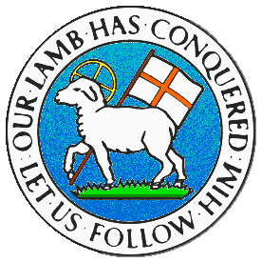
CHILDREN BROCHURE

MORAVIAN CHURCH – BARBADOS CONFERENCE
Provincial Theme: Advance the Kingdom: S.H.I.F.T.

S. – Seek & Submit
H. – Hear & Heed
I. – Imagine & Insight
F. – Focus & Function
T. – Totally Transformed

Age: 7 yrs. & Under
S.H.I.F.T.

December 12

Scripture:

Proverbs 1:23 Turn at my rebuke. Surely I will pour out my spirit on you; I will make my words known to you. (NKJV)

Message:

When your mother or father tries to correct you as you do something wrong, you may feel as if they are picking on you. But you must remember for them to speak to you, it means that you did something wrong in the first place. Many of us do not like to be corrected for doing the wrong thing. Either we feel we did no wrong or we do not want others to correct us and set us on the right pathway. But good things can happen when we accept correction as well as help us to turn from our wrong ways.

The Lord rebukes or corrects us when we do wrong. He points out to us the need to make a change so that there will be a difference in our lives. And with the correction comes the blessings. When we turn away from doing wrong, God will pour out His Spirit upon us, making us new persons with a new attitude. It will help us to focus on doing and living right. He also promises to fill us with the word of God. This will give us the knowledge and understanding to move forward.

Activity:

Exchange the symbols for letters.

A | E | I | O | U
Ω | ∞ | ± | ≥ | £

L ± v ∞ g ≥ ≥ d;
D ≥ t h ∞ r ± g h t;
L ± v ∞ f ≥ r J ∞ s £ s C h r ± s t.

(Answers next week)

(Answers from last week)

A good name is better than fine perfume. Ecclesiastes 7:1

