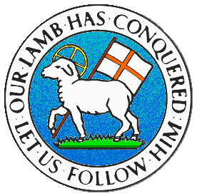
CHILDREN BROCHURE

MORAVIAN CHURCH – BARBADOS CONFERENCE
Provincial Theme: Advance the Kingdom: S.H.I.F.T.

S. – Seek & Submit
H. – Hear & Heed
I. – Imagine & Insight
F. – Focus & Function
T. – Totally Transformed

Age: 7 yrs. & Under
S.H.I.F.T.
August 29

Scripture:

Mark 12:30 “And you shall love the Lord your God with all your heart, with all your soul, with all your mind, and with all your strength.' This is the first commandment. (NJKV)

Message:

When you enjoy doing something, you put all your energy into the activity. If you enjoy going to the beach, you make sure you plan properly so that the day is perfect. You begin by packing from the night before, putting all your beach clothes, towels, shoes and toys in a bag with all your snacks. You even help your mother to prepare the food. The next morning you are up early after hardly sleeping the night before to help in the final efforts to get to the beach quickly. You are so excited about spending the day with your friends and relatives.

We should be even more excited when it comes to our relationship with Jesus Christ. We should put our everything into serving Him. We must put our heart, mind, soul and strength into loving the Lord. In other words, don’t hold back by giving just a bit and not our all. When we love the Lord with all we have, He loves us back in a very large way and we can depend upon that. We know the whole world is His which means He has a lot in store for us if we trust Him. Give Him your all and He will take care of you.
Activity:

Strength soul heart mind
Love Lord first God

Use the words in the list to complete the verse below.

“And you shall l______ the L______ your G_____ with all your h_____, with all your s______, with all your m______, and with all your s______.' This is the f______ commandment.
Mark 12:30

(Answer next week)

