CHILDREN BROCHURE

MORAVIAN CHURCH – BARBADOS CONFERENCE
Provincial Theme: Advance the Kingdom: S.H.I.F.T.

S. – Seek & Submit
H. – Hear & Heed
I. – Imagine & Insight
F. – Focus & Function
T. – Totally Transformed

Age: 13 yrs. & Over

IMAGINE

AUGUST 23 – The Cost of Discipleship

Scripture:

Song:

I’m not ashamed to own my Lord

Sing with me

https://www.youtube.com/watch?v=OCXu-LZJX8w

1. I’m not ashamed to own my Lord,  or to defend His cause;  maintain the glory of His cross  and honour all His laws.  Chorus:  2. Jesus, my Lord! I know His name,  His name is all my boast;  nor will He put my soul to shame,  nor let my hope be lost. | Chorus:  At the cross, at the cross, where I first saw the light,  and the burden of my heart rolled away,  it was there by faith I received my sight,  and now I am happy all the day. ...... | 3. I know that safe with Him remains,  protected by His power,  what I’ve committed to His hands  till the decisive hour.  4.Then will He own His servant’s name  before His Father’s face;  and, in the new Jerusalem,  appoint my soul a place.

Memory Verse: Luke 9:23

23 Then he said to all of them, “Whoever wants to follow me must say no to themselves. They must pick up their cross every day and follow me
(Read with me)
Luke 9:23 - 26
23 Then he said to all of them, “Whoever wants to follow me must say no to themselves. They must pick up their cross every day and follow me. 24 Whoever wants to save their life will lose it. But whoever loses their life for me will save it. 25 What good is it if someone gains the whole world but loses or gives up their very self? 26 Suppose someone is ashamed of me and my words. The Son of Man will come in his glory and in the glory of the Father and the holy angels. Then he will be ashamed of that person.
Message:
Let’s talk about it.
Jesus has been preaching and teaching since the day that He called His first disciples, (Matthew 4, 18 – 22; Mark 1:16 – 24). Wherever Jesus went, a crowd of people was there. Everyone wanted to follow Jesus. But Jesus wanted people to do more than just follow Him. Jesus wanted people to understand what it really meant to be a disciple. He told them that if they wanted to follow Him and be a true disciple, there are certain sacrifices that must be made. As a young person, Jesus is calling you to be a disciple, and, yes, you want to be a disciple, but are you really making it?
Think about this. Saturday afternoon, your school friends are planning to go to the movies, you have steel pan practice at church the same time as the movies. What do you do? You have a choice. If you really want to be a disciple, then you will go to steel pan practice because you want to be the best steel pan player. Plus, there is a concert on Sunday and you are part of the performing orchestra. What is Jesus asking of you? Is Jesus really asking you to give up an evening with your friends so that you can serve Him?
Are you ashamed to invite your friends to youth meeting? Are you ashamed to let your friends know that you read your Bible and pray? Jesus tells us that we must let our friends know about him. Do not be ashamed to tell your friends about Jesus.
Even in your family, Jesus says there are sacrifices. Jesus has always encouraged us to obey the command, “honour your father and mother….” But at the same time, in a respectful way, you must put God first.
What is your cross? Your cross is the many choices that you have to make daily. Sometimes the cross will seem heavy, because you are not sure which way to go, but remember Jesus already carried the heavy cross. You are asked to make choices. As a disciple of Jesus, ask God to help you make the right choice.
The song writer says “ Read your Bible, pray every day, and you will grow.” Growth there means that you will be strong enough to say “no” to many temptations that may come your way. As you read and study the Bible, you will get stronger and develop greater faith in Jesus. Look to God to help you to make choices for Him.

Let us pray.
Good and Gracious God, Your Son, Jesus Christ, invited all people to follow Him and become His disciples. Come into my heart, enlighten my mind, and stir my spirit to serve You.
Help me daily to take up my cross and follow Jesus, by living His Word and telling those around me the Good News about Him. May my faith in You increase, and may my hunger for the Gospel be strengthened as I learn to love others as Jesus has loved me. Amen.

(Answers from last week)

1.B 2.B 3.B
4.C 5.A 6.B

Activity:

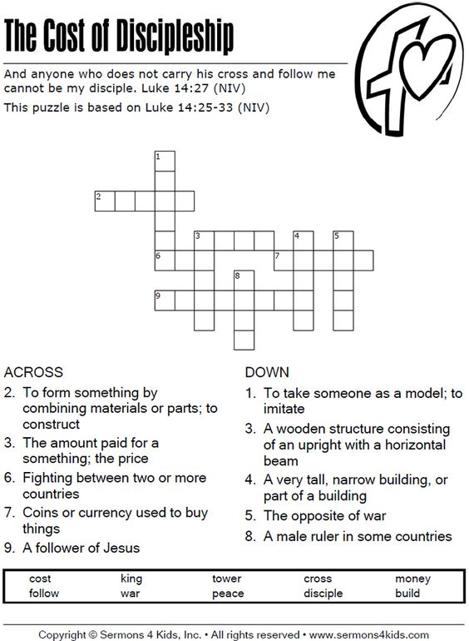

(Answers next week)

