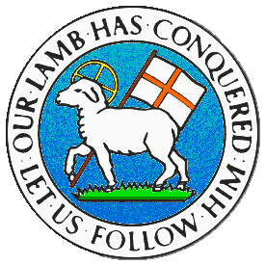
CHILDREN BROCHURE

MORAVIAN CHURCH – BARBADOS CONFERENCE
Provincial Theme: Advance the Kingdom: S.H.I.F.T.

S. – Seek & Submit
H. – Hear & Heed
I. – Imagine & Insight
F. – Focus & Function
T. – Totally Transformed

Age: 7 yrs. & Under
S.H.I.F.T.

August 15

Scripture:

Luke 11:31 “Seek the Kingdom of God above all else, and he will give you everything you need.” (NLT)

Message:

There are many things you want to do in life. You would love to go to different places to see what it is like as well as to eat the different foods. It would be wonderful if you could meet your favourite movie or sports star. If you love fast food, you would eat out ever so often. You have a list of things to do and don’t know which to do first and which to leave until a little later. And if you are able to choose, will you make the right choice. You even worry about what you will eat and if what you have is enough for you and your family.

When we place our trust in Jesus, we have no need to worry about what to eat or wear. We will also be guided in making the right choices and in the right order. We must however set our priorities and do the right thing first which is to seek the Kingdom of God. Seek Jesus Christ and make it right with Him. Have a good and strong relationship with the Lord. Live the true and correct life without sin. Put God first and He will give you all you need so that you do not have to worry and fret. Put God first.

Activity:

Fill in the blanks from the table, then listen to the song.

A | E | I | O | U
∞ | ≤ | ◊ | ¥ | ©

Why w¥rry wh≤n y¥© c∞n pr∞y,
S≤≤k J≤s©s H≤ w◊ll m∞k≤ ∞ w∞y,
D¥n’t b≤ l◊k≤ d¥©btf©l Th¥m∞s,
J©st r≤st ©p¥n H◊s pr¥m◊s≤,
Why w¥rry w¥rry w¥rry wh≤n y¥© c∞n pr∞y.

https://youtu.be/MVXlPGWs358

(Answer next week)

