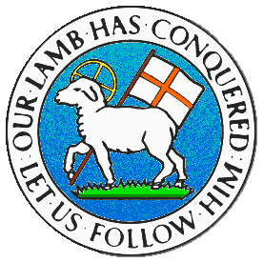
CHILDREN BROCHURE

MORAVIAN CHURCH – BARBADOS CONFERENCE
Provincial Theme: Advance the Kingdom: S.H.I.F.T.

S. – Seek & Submit
H. – Hear & Heed
I. – Imagine & Insight
F. – Focus & Function
T. – Totally Transformed

Age: 7 yrs. & Under
S.H.I.F.T.

April 11

Scripture:

Philippians 4:13 "I can do all things through Christ who strengthens me.” (NKJV)

Message:

Remember when you were trying to do something on your own and it was just not working out? Everything was not coming together and was falling apart. But when your friend came and helped you, things worked out differently, they were much better. It is the same and even better with our friend Jesus Christ. On our own, we may struggle and not get very far. But when we do things with Him, we can go for a very long time, go a long distance and get a lot of things done.

Jesus Christ is the strength we need to see us through all our situations and our troubles. He is the strength we need in these Covid times and if He has helped us in the past, He will surely help us now. When we are able to get things done, let us not think that we did it all on our own, but remember Jesus was with us at every step. So when we see difficult spots along the way, just say a prayer to the Lord and ask for His help. Always make sure you are on the right road and He will help you to make the right choice to succeed.

Activity:

Give the opposite to the words underlined to see the verses of strength:

1.

I cannot do some things through Christ who weakens me.” Philippians 4:13

2.

He gives power to the strong and weakness to the powerless. Isaiah 40:29

(Answers next week)

